SEE UPDATEs…This is all the information I have
1. (HD)

**Full page
The Assignment 1

Imagine that you’re the corporate communications vice president for Harley-Davidson Motor Company. To promote motorcycle use in the United States, you’re planning a communication campaign focused on safety. Your objective is to overcome the public’s perception that motorcycles are dangerous. You decide to include some scholarly research to support your point of view. But, of course, you want to present an ethical argument, so you’ll evaluate each study carefully. Discuss the following questions from “Evaluating Research Studies” to ensure the studies meet your quality standards:

(1) What was the purpose of the study?,
(2) How was the data collected?,
(3) How was the data analyzed?,
(4)How consistent is the data with that from other studies?,
(4) How old is the data?

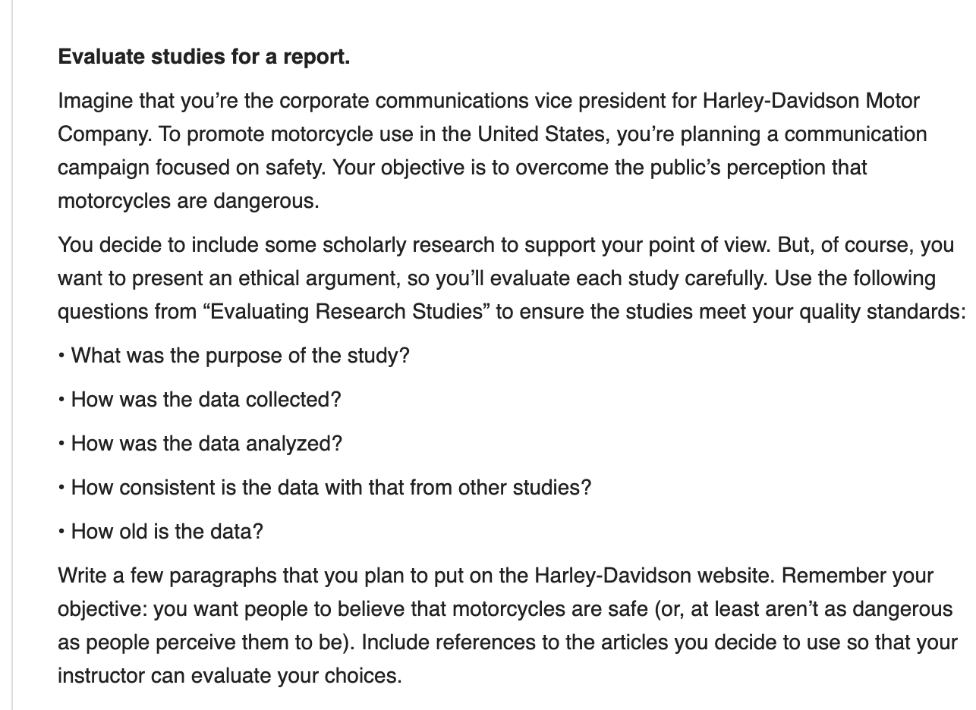

2 (Play for Profit

**Full page
Assignment 2 (see sample below)

For this writing task, you''ll need to respond to the following scenario:
Who are you?
You are the vice president of operations at Exquisite Entertainment, an entertainment company that owns and operates 19 seasonal and year-round amusement parks (Worlds of Play) located throughout the U.S. You are responsible for providing overall direction and guidance with regard to the operational activities of the organization.
What''s the current situation?
The company''s amusement parks have always been popular, but recently they haven''t been very profitable. Operating costs have been rising, and every dollar of extra revenue has been hard won. At the company''s annual management offsite meeting held that morning at Worlds of Play-Seattle, Alex Harrington, a business strategy consultant from Ernst & Young LLP, unveiled "Operation Upmarket," a business strategy proposal aimed at addressing the issue of profitability for Worlds of Play. This plan proposed that Worlds of Play offer its customers the option of a "preferred guest" card. Cardholders would pay more, but they would get first crack at the rides and would get seated immediately at any of the park''s restaurants. According to Alex, the plan would help Worlds of Play finances because it would target the "mass affluents"--wealthy but time-pressed people who might visit the park more often and spend more time while there, were it not for long lines at the rides.
You think back to that morning's meeting. You respect Alex's plan, but what about the initiatives you had implemented to tap into that same segment? In fact, you have already had some successes. Roughly 20% of Worlds of Play souvenir shops have been upgraded to gift boutiques with more appealing displays and higher-priced merchandise, and some snack concessions have been converted to seated dining. The most upscale of the restaurants are already earning almost double the profit per square foot of the other food-service facilities.
Alex had done an impressive amount of work developing the idea, commissioning surveys and focus groups, and getting finance to run the numbers. Her presentation had been persuasive, you admit. Her tactic had been to get people arguing the details--should the pass cost $20 more than general admission or $30 more?--while ignoring the question of whether it was a good idea at all. At first, this approach seemed to be working. But Grace Jones, Exquisite Entertainment's vice president of human resources said, "Clearly, there's revenue to be gained from offering these differentiated service levels. But it just doesn't seem like us. The founder of Worlds of Play created a place where families could come together for a day to forget about their cares." Alex said, "Our history is great, but if things don't turn around fast, we are going to be history. The company has to make changes quickly to avoid cash-crunch-driven bankruptcy or a hostile takeover."
It was no secret to anyone in the meeting that theme parks have only three ways to bring in more revenue: (1) increase visits per customer, (2) increase average spending per visit, or (3) attract new customers. Alex argued that the guest card would address the last two items by attracting a different type of customer--time-starved, high-income professionals and their families--who might otherwise avoid the whole experience.
Adam Goodwin, the VP of marketing said, "It strikes me as a very shortsighted strategy. I mean, sure we could make a lot of money on those cards in the first couple of seasons. But just think about what it does to the overall customer experience. The average Joe with his wife and three kids is not going to shell out for five upgrades. So they are going to be sweating through even longer lines and just steaming when they see some yuppie waltz ahead of them. I don't even think it's a great experience for the preferred guests. Who wants to feel all the anger directed at them? The key to this business is that the customers feel good while they are here. A couple of ugly glances, a nasty remark, and the day is spoiled for everybody. Neither side's coming back."
"I should have explained," Alex said. "We would definitely separate the lines so the preferred cardholders wouldn't be in people's faces and we'd limit the percentage of special tickets issued on any given day. But I don't think you are giving your customers enough credit. People have a lot more awareness and appreciation of the fact that time is money. This program lets them choose which they want to save."
What are you supposed to do?
You have been charged by CEO XYZ to summarize the merits of the option presented at the meeting in his absence. Craft the body of a document for Mr. XYZ
Develop a response that includes examples and evidence to support your ideas, and which clearly communicates the required message to your audience. Organize your response in a clear and logical manner as appropriate for the genre of writing. Use well-structured sentences, audience-appropriate language, and correct conventions of standard American English.

***(Assignment 2) Sample:***
XYZ name
Chief Executive Officer
Exquisite Entertainment
Dear XYZ,
On June 19 we met with XYZ, a business strategy consultant at XYZ & XYZ, to discuss her proposal on how to increase World-of-Play's profits. Her strategy gives customers the option to purchase a "preferred guest" card. The card would cost customers a premium, but allow them to have priority to rides and dining services. For example, if a customer has a "preferred guest" card they could skip the long lines and go straight to the front. They would also be seated first at all park restaurants.
XYZ tactic was to get everyone arguing over how much the premium should be-should it be $20 or $30 more? However, several key personnel raised questions about whether it was a good idea at all. XYZ brought up the point that the strategy did not seem to be in harmony with the overall purpose of the company. She stated that the goal of the company is to create a place where families can come have fun and get away from all their worries.
XYZ, the VP of marketing, thinks that Alex's strategy is a shortsighted strategy that would generate much revenue in the first few years. However, he was unsure if it would really help our profits in the long-run. His main concern is to create an environment that families will want to come back to. XYZ also stated that the key to this business is that the customers feel good while they are here.
The introduction of preferred guest cards can have detrimental effects to the overall experience at Worlds of Play. The ability to pay to cut lines will anger average families who are unable to afford the preferred guest cards, and preferred guest card holders will also feel antagonized as they feel resentment from our other customers. In the long term, XYZ plan may actually lower the attendance rate at our amusement parks.
It is no secret that we need to make changes quickly to avoid bankruptcy. We have three ways to increase revenues -- (1) increase visits per customer, (2) increase average spending per visit, or (3) attract new customers. XYZ strategy addresses the last two items by attracting high-income families that would otherwise not come.
I have implemented some new strategies targeted to wealthier customers. We have upgraded twenty of our souvenir shops to gift boutiques. We have also converted some of the snack concessions to restaurants. These restaurants are earning twice the profit than other food facilities in the park.
I think XYZ strategy could be a good way to get money fast which would solve our immediate financial problems. However, as a long-term solution I would suggest that we continue to develop the concession stands into a variety of different restaurants. This market has largely been untapped and I think that this would provide a long-term solution to our issues at hand. What I would suggest is to have a test-run of the "preferred guest" card for one year. Not only would this generate fast cash, but it would also test customer reactions to this strategy.
As vice-president of Exquisite Entertainment, I hope you have found the summary of this meeting helpful in answering some of your questions. I would like to follow up with you about this meeting tomorrow morning June 20 at 9:00 a.m.
Sincerely,
XYZ vice-president of Operations
Exquisite Entertainment

3 OB in the US
Full page
**Assignment 3
Convert Generic Headings to Message Titles
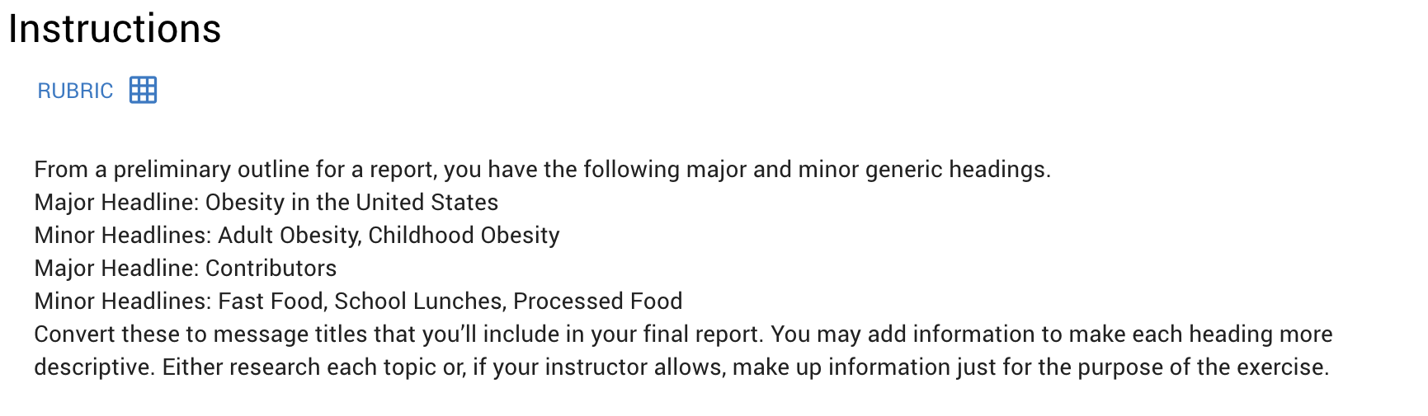

From a preliminary outline for a report, you have the following major and minor generic headings.
Major Headline: Obesity in the United States
Minor Headlines: Adult Obesity, Childhood Obesity
Major Headline: Contributors
Minor Headlines: Fast Food, School Lunches, Processed Food
Convert these to message titles that you’ll include in your final report. You may add information to make each heading more descriptive. Either research each topic or, if your instructor allows, make up information just for the purpose of the exercise.

